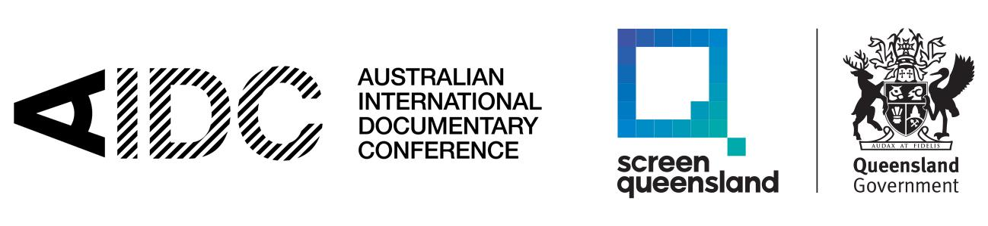

### **REGIONALITY SUNSHINE COAST 2025**

### **REGISTRATION TERMS AND CONDITIONS**

By registering for Regionality Sunshine Coast 2025, you (the ‘delegate’) understand and agree that:

**1. General**

1.1 By registering for this event you agree to abide by all AIDC Regionality Sunshine Coast 2025 Terms and Conditions. Failure to abide by the Terms and Conditions may result in you being asked to leave the Conference.

1.2 In 2025, AIDC will deliver Regionality Sunshine Coast 2025 as an in-person event.

1.2.1. The in-person event delivery consists of:

In-person sessions and activities on Monday 28 July 2025 in Mooloolaba, Queensland, at Mantra Mooloolaba Beach and other venues (the ‘Event’)

1.3 All delegate registrations are non-transferable. It is a condition of attendance that your registration cannot be used by another person.

1.4 Unauthorised recordings and/or distribution of material recorded at the Event without permission constitutes a breach of copyright and is prohibited.

**2. Conditions of Entry**

2.1. The Australian International Documentary Conference (“AIDC”) has zero tolerance for unsafe behaviours, including all forms of harassment, discrimination and bullying based on race, gender, religious belief, disability, sexual orientation or illness. By registering for this event you agree to abide by all Regionality Sunshine Coast 2025 terms and conditions. Failure to do so may lead to delegates being asked to leave the Event.

2.2 Photo ID must be shown when collecting your registration pass

2.3 All delegates must adhere to conditions of entry at all Regionality Sunshine Coast venues.

2.4 A Delegate must not attend the Event, and Regionality Sunshine Coast 2025 venues, have the right to refuse entry, if they:

2.4.1. are showing symptoms of the COVID-19 or any flu like symptoms or feeling otherwise unwell; and/or

2.4.2 have been asked to leave the Event as a result of a breach of clause 2.1.

**(“Reasons for Refusal”)**

2.5 AIDC reserves the right to refuse a Delegate entry to the Conference if any of the above Reasons for Refusal applies to a Delegate.

2.6 These conditions of entry are subject to change without notice and at the discretion of Regionality Sunshine Coast 2025 venues and/or AIDC

**3. Permission to Use of Recordings of Delegates**

3.1. All registered delegates grant AIDC permission to use visual or sound recordings  
made during the Event that includes their image or voice, in whole or in part, for any promotional and/or publicity and/or reporting purposes directly related to AIDC and AIDC’s partners or sponsors (“**AIDC Purposes**”)., in any format now known or hereafter devised, in perpetuity.

3.2 If delegates do not wish their image or voice to appear in AIDC promotional material, they will be given the chance to notify AIDC registration staff of this during the Event.

**4. Pricing**

4.1. All prices are in Australian dollars and GST inclusive but exclusive of credit card charges. Charges are 2.5% of the total purchase price and will be charged upon checkout.

**5. Passes**

5.1 Delegates may purchase one type of registration that allows in-person access to the Event.

5.2 Registration Includes:

5.2.1 In-person entry to the Event at Mantra Mooloolaba Beach on Monday 28 July 2025

5.2.2 In-person entry to all sessions

5.2.3 In-person access to Doc:Chat meetings (if selected only)

5.2.4 In-person entry to networking activities

5.3 Note: the pass does not guarantee entry to sessions with limited capacity that  
 require prior booking

**6. Use Of Email And Personal Information**

6.1. All registered delegates will have their email address added to the e-newsletter subscription lists unless they choose to opt out.

6.2. While registering, delegates can opt out of their contact details being published.

**7. COVID-19 Compliance**

7.1. You acknowledge that COVID-19 is an extremely contagious virus and the elimination of risk, exposure and infection is not currently possible. As required, the Event will be conducted in accordance with the Queensland Government’s COVID-19 directions and the delegate agrees to take and comply with all measures imposed by AIDC to mitigate the risks of transmission.

7.2. You must comply with any and all COVID-19 safety protocols put in place by AIDC at the Event displayed on signage throughout the Event. This may include but is not limited to:

7.2.1 Ensuring compliance with social distancing measures of at least 1.5 metres apart wherever possible (including when queuing);

7.2.2 Person and density limits for certain areas;

7.2.3 Complying with all Government health directions, including the wearing of masks;

7.2.4 Hygiene requirements, including hand sanitation;

7.2.5 Minimal use of cash, using contactless payments; and

7.2.6 Other safety requirements as directed by the Queensland government.

7.3 AIDC will continue to monitor and refer to Queensland Government and Safe Work Australia websites for up-to-date information and additional resources for preparing the Event. AIDC reserves the right to update the COVID-19 safety requirements without notice to the delegates at any time and without notice in accordance with Government direction and mandates.

**8. COVID-19 Release**

8.1. You acknowledge that due to the contagious nature of COVID-19, by attending in-person sessions you are at risk of contracting COVID-19 or related illnesses which may result in severe or permanent damage to your health and that:

8.1.1 You are attending the in-person sessions at your own risk;

8.1.2 You have evaluated all risks involved with attending the in-person sessions, including but not limited to whether you are immunocompromised;

8.1.3 You voluntarily accept and assume the risks and dangers you may encounter at the in-person sessions;

8.1.4 You acknowledge that you may be exposed to COVID-19 as a result of the actions, omissions or negligence of yourself or others, including but not limited to the directors, officers, employees, representatives, contractors (and their respective employees), invitees or agents of AIDC; and

8.1.5 You acknowledge full and complete assumptions of the risks.

8.2 By agreeing to these terms and conditions, you release and discharge AIDC or its officers, employees and agents for any injury, illness, damage, loss or harm, disability or death to you or otherwise, resulting or arising out of or in any way related to preparation for, travel to, attendance at, and participation in the Event. To the maximum extent permitted by law, AIDC will not be responsible for any loss, damage, personal injury, illness, permanent disability or death arising from your attendance at the Event.

**9. Cancellation, Refund & Exchange Policy**

9.1 Cancellations and refund requests must be received in writing to info@aidc.com.au before 23:59pm (AEST) on Sunday 13 July 2025 (two weeks prior to the event). If accepted, a full refund of your registration fee can be provided, less transaction fees and less a cancellation fee of AUD$15 + GST. No refunds will be available after 12:00am (AEST) Monday 14 July 2025.

9.2 No refunds will be offered if you are refused entry or do not meet the conditions of entry as set out above.

9.3 No refunds will be offered if you do not wish to attend the in-person sessions due to being in a higher risk group or fear of exposure to COVID-19.

9.4 The following cancellation terms apply in the following circumstances:

9.4.1. Change of Mind

No refunds will be provided after 12:00am (AEST) Monday 14 July 2025 for change of mind.

9.5 Exchange requests are at the sole discretion of AIDC and must be received in writing to info@aidc.com.au. If accepted, delegates will be notified and a new registration issued. Any price difference will be charged or refunded less a service fee of $15 AUD+ GST.